CATT Hybrid ITMO Modifying and Developing Materials

**Sourcing Materials in English**

There are a variety of steps to take to source materials in English, which basically boil down to two ideas: conducting internet searches in a wide variety of places, and developing relationships with publishers and their representatives. This packet will share steps for both to guide you in beginning to source English materials for your field and your purposes.

***Internet Searches to Source Materials in English***

There are many routes to take with internet searches to find English materials. Go through the list below to see some options.

1. ITMO Libraries

What resources do you already have available through your university library system?

<http://en.ifmo.ru/en/page/57/Libraries_&_Open_Data.htm>

Take a few minutes to click through the resources linked from this page to have a sense of what is available to you at home. Save the link and make it your starting point when looking for something new at home.

Example: Springer has about 890 computer science textbooks

<http://www.springer.com/gp/product-search/discipline?disciplineId=computerscience&facet=type__book%2Clan__en&facet-type=categorybook__pcytextbook&returnUrl=gp%2Fcomputer-science&topic=I00001%2CI1200X%2CI12018%2CI12026%2CI12034%2CI12042%2CI12050%2CI12069%2CI12077%2CI13006%2CI16013%2CI13014%2CI1603X%2CI13049%2CI13057%2CI14002%2CI14010%2CI14029%2CI14037%2CI14045%2CI14050%2CI15009%2CI15017%2CI15025%2CI15033%2CI15041%2CI1505X%2CI16005%2CI16021%2CI16048%2CI17001%2CI1701X%2CI17028%2CI17036%2CI17044%2CI17052%2CI18008%2CI18016%2CI18024%2CI18030%2CI18032%2CI18040%2CI18059%2CI18067%2CI21009%2CI21017%2CI21025%2CI21033%2CI21041%2CI22005%2CI22013%2CI22021%2CI2203X%2CI22040%2CI23001%2CI2301X%2CI23028%2CI23036%2CI23044%2CI23050%2CI23060%2CI24008%2CI24016%2CI24024%2CI24032%2CI24040%2CI24059%2CI24067%2CI24075%2CI24083%2CI25004%2CI27000%2CV24000>

2. University of Arizona libraries

While on campus at UA, you have access to the UA library (you won’t have full access off-campus at your housing). Search and find as much as you can while here, and upload materials to take home and use.

UA libraries home page:

<http://new.library.arizona.edu/>

Search our library catalog for books, e-books and journal articles:

<http://new.library.arizona.edu/#catalog>

Search our databases:

<http://new.library.arizona.edu/#databases>

Make an appointment with a research librarian at UA to get individualized, expert help finding the resources you need in your field. Find the research librarian who specializes in your area on a subject-specific page:

<http://new.library.arizona.edu/research/subject>

3. Google Scholar

<https://scholar.google.com/>

Search Google scholar to focus on scholarly sources. Google Scholar also often has downloads available.

4. Academic Social Media

There are a variety of academic social media platforms now, like Mendeley (also stores and manages research articles), academia.edu and Research Gate. After you sign up for an account there, you can “follow” people in your field whose recent research you want to know about, and you can enter your areas of interest and receive notifications when new scholars or publications in the same area come up. Explore these a bit and see if it might help you.

<https://www.researchgate.net>

<https://www.academia.edu>

<https://www.mendeley.com>

***Develop a Relationship with Publishers and their Representatives***

1. Request “desk copies” or “review copies” of textbooks for your classes. Try to look several months in advance so you have time to get and review multiple books before you decide if one text fits your class needs.

* Find the book you are interested in at the publisher’s website (not at a website that sells books from multiple publishers like Amazon). For example:

<http://www.springer.com/gp/book/9783319516547>

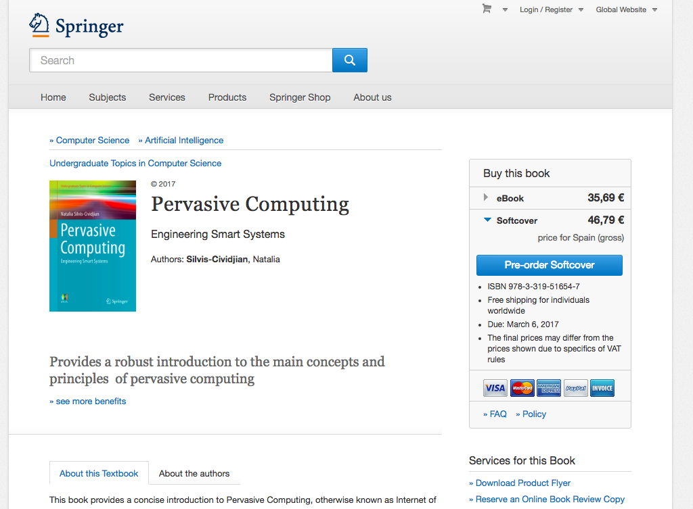

* Look for a link about ‘review copy’, ‘desk copy’, etc. (If there are no links about this, then move to #2).

<http://www.springer.com/services+for+this+book?SGWID=0-1772415-3261-0-9783319516547>

* Create an account (in this case, with Springer), or fill in the requested information to get a review copy. It is most common to have e-copies for review, but you may sometimes be able to get the actual book (though this obviously takes longer).

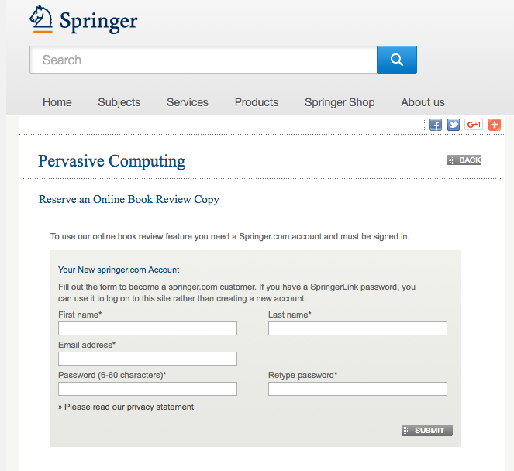

2. *Other ways to stay up-to-date on textbooks in your field*

* Email, write or call the publisher representative for textbooks in your teaching area.
* Ask to be put on mailing lists to notify you of new sources in your field.
* If you are active on social media, follow the publisher and/or publisher reps on Facebook, Twitter, etc. to see their announcements of new texts there.
* Reach out to the publisher or publisher representative when you have questions about textbooks (arrival of new editions, teaching resources that go with the book, online resources for students, different treatment of a similar topic, etc.).

**Copyright information**

Review the following links to understand how to use copyrighted sources legally in your teaching. Generally speaking, you may use 10% or one chapter of a book in your class without asking students to buy the book. If you use more than that, all of your students should buy a copy of the book (e-book or print copy).

General information: <http://new.library.arizona.edu/research/copyright>

Fair use: <http://new.library.arizona.edu/research/copyright/fair-use>

Educational exceptions: <http://new.library.arizona.edu/research/copyright/instructors>